**Introduction**

* 1. **ABOUT E-Commerce Web Application**

Online shopping is fast gaining ground as an accepted and used business paradigm. More and more business houses are implementing web sites providing functionality for performing commercial transactions over the web. It is reasonable to say that the process of shopping on the web is becoming commonplace. The objective of this project is to develop a general purpose e-commerce store where product like clothes can be bought from the comfort of home through the Internet. However, for implementation purposes, this paper will deal with an online shopping for various kinds of products. An online store is a virtual store on the Internet where customers can browse the catalog and select products of interest. The selected items may be collected in a shopping cart. At checkout time, the items in the shopping cart will be presented as an order. At that time, more information will be needed to complete the transaction. Usually, the customer will be asked to fill or select a billing address, a shipping address, a shipping option, and payment information such as credit card number. An e-mail notification is sent to the customer as soon as the order is placed. In today’s fast-changing business environment, it’s extremely important to be able to respond to client needs in the most effective and timely manner. If your customers wish to see your business online and have instant access to your products or services. Online Shopping is a lifestyle e-commerce web application, which retails various fashion and lifestyle products. This project allows viewing various products available enables registered users to purchase desired products instantly using Visa payment processor (Instant Pay) and also can place order by using Cash on Delivery (Pay Later) option. This project provides an easy access to Administrators and Managers to view orders placed using Pay Later and Instant Pay options. In order to develop an online shopping website, a number of Technologies must be studied and understood. These include multi-tiered architecture, server and client side scripting techniques, implementation technologies such as PHP and relational databases. This is a project with the objective to develop a basic website where a consumer is provided with a shopping cart application and also to know about the technologies used to develop such an application. This document will discuss each of the underlying technologies to create and implement an ecommerce website. Pakistan is a developing country. Our people try to improve their future. They are always busy for their work. They have no time to go to a market for shopping. So the time and place are very important. E-Commerce management system is one kind of Online shopping is the process whereby consumers directly buy goods or services from a seller in real-time over the internet. An online shop or e-shop or virtual store evokes the physical analogy of buying products or services in a shopping mall, which already exists. But in our country most of the people are not familiar with this new system. So we’ll try to develop an Online shopping Management system where payment system by using mobile, that can everybody familiar and take the benefits of online shop.

1.2 AIMS AND OBJECTIVES

The main objective of this project is to develop an Online shopping Web Application, which are familiar to our people with an online shop or virtual store and the shopping cart system. Our system brings with it a lot of advantages. To remain honest with our topic, we take a brief look at the main objectives:

• Our system overcomes Geographical barriers by making it possible to shop from virtually from anywhere in our country providing e-commerce shopping platforms

• Our Online shopping project is also a hassle free and sometimes even an enjoyable purchasing activity as customers need not walk to stores, carry heavy loads of their purchases back home, nor does it involve communication and burning fuels. And it does some favor to the environment by limiting the emission of toxics with lesser use of retail outlets and avoiding congestion.

The main aim of Online shopping management system:

• Enable to maintain a large amount of customer information.

• Enable to maintain a huge collection of information

• Quickly view the current status of a customer

• Provide quickly and easy search of any category of products

• Provide easy transaction and sales of product

• Provide accurate account information for product purchase

• Generate automated order receipt

• Provide three layer security

• Provide an auction system to buy an exclusive product

* 1. INVESTIGATIONS

This is the second phase of the system Development Life Cycle. This phase is very important in this phase I will get to know the organization behavior for which I’m doing my project I have visited few super shops. Some of them are maintaining manual system, but large super shops are maintaining point of sale (POS) system. I find that every manual system has lacking and problem in their system. In this age of IT, now it more possible to maintain manual system in organization moreover super shop must use POS for quick access of data and for become faster in service. So I’ll like to develop an online system for help those super shops that are not using POS yet and for those people who are want to be free from harassment to buying things. Initial investigation is the phase, where we will understand what we have to do in this project, we will determine here, what about the project is? What the project need, what is current status of the project and what are the problems with the current system. As I am going to develop a general system, so I will use strategies of several companies and generates a single solution.

1.4 PROBLEM STATEMENT

As a sample when a person wants some thing he/ she first have to drive to the local store then walk throughout the store until he/ she locates the book he/ she needs. After finding the product if he/ she want to purchase, he/ she may often need to stand in long queue at cash counter for long time. I have some problem in the above systems that’s:

• Needs more time to searching a specific product.

• It is so time consuming to get daily sales report

• Sometime calculation may wrong

• Need more man power to maintain the whole shop such as purchase and Generating order

• To manipulate the products by category it’s so difficult.

• To generate invoice and store the invoice needs no more place

• Sometimes files may be destroyed by cockroach or by another way

• It is insecure

The online shopping is the best and convenient way for shopping. It helps consumer to avoid the disadvantage of traditional or manual shopping system. With the help of E-commerce system which has been developed for all people, consumer can buy a variety of items from the online store to see the details and they have multiple chose to payment.

1.5 EXISTING SYSTEM

A customer visits the online shopping portal. A customer may buy item or just visit the page and logout. The customer can select a segment, then a category, and brand to get the different products in the desired brand. The customer can select the product for purchasing. The process can be repeated for more items. Once the customer finishes selecting the product/s the cart can be viewed, If the customer wants to edit the final cart it can be done here. For final payment the customer has to login the portal, if the customer is visiting for the 1st time he must register with the site, else the customer must use the login page to proceed. Final cart is submitted for payment and card details and address (where shipment has to be made) are be confirmed by the customer. Customer is confirmed with a shipment Id and delivery of goods within 3 working days. As it is a general system, I will try to design the system in a way that everyone can use it frequently. So I choose the common events that all the general people use it and then a graphical presentation of report will generate by the system.

**Analysis**

2.1 OVER VIEW OF THE EXISTING SYSTEM

We can divide our present shopping system in two ways. There are: ¬ Traditional or manual shopping system, and ¬ Online shopping or electronic shopping system. The traditional or manual shopping system is the process where, when a customer needs to buy something, first needs to think from where he/ she can get it. Then drive to the specific shop or market, choose the products, bargain for prize. If he/ she want to purchase finally, he/ she may often need to stand in long queue at cash counter for long time. This type of shop or market are not fulfill your requirement all the time and don’t serve you 24 hours of a day. Also to go from one shop to another is killing your precious time. One the other-hand Online shopping system or electronic shopping system is the process where customers directly buy goods or service from a seller. By the help of internet shopping customer take a hassle free and sometimes even an enjoyable purchasing activity. But the existing online shopping system is not popular in our country. All online shopping system which are exist, they use their payment system by VISA card, Master card or etc. But in our country, those type of card use only top level person or very rich man in our society. So, in our country, the present online shopping system is not familiar and popular.

2.2 SIMILAR PROJECTS IN MARKETPLACE:

1. Yayvo https://www.Yayvo.com

2. Ali Express <https://www.aliexpress.com>

3. Daraz https://www.daraz.pk

2.3 POSSIBLE SOLUTION

Our proposed system is little different from existing shopping system. Pakistan is a developing country. A big population of our country can’t use online shop. They don’t know the system, process or mechanism of online shop. So we are added some new features with the existing Online shopping system. They are

01. View All product details Easily 02. Easy payment system 03. Quickly Delivery process 04. Generate Secure Delivery Card 05. A total help guide, and 06. A customer care.

2.4 USED TECHNOLOGY

The automated Online shopping management system is based on any windows environment. To run the system only need any popular browser. To do this, following tools and technologies are used. SOFTWARE REQUIREMENTS: ¬ MVC FRAMEWORK – JQUERY , AJAX ¬ SCRIPTING LANGUAGE – C#, JAVA SCRIPT ¬ DATABASE SERVER – MYSQL ¬ WEB SERVER – APACHEE ¬ OTHER LANGUAGE – HTML , CSS, BOOTSTRAP ¬ ¬ OPERATING SYSTEM – WINDOWS 7/8/10 HARDWARE REQUIREMENTS: ¬ RAM 1 GB ¬ HARDDISK 10 GB

**Design**

**3.1 WORK FLOW DIAGRAM**

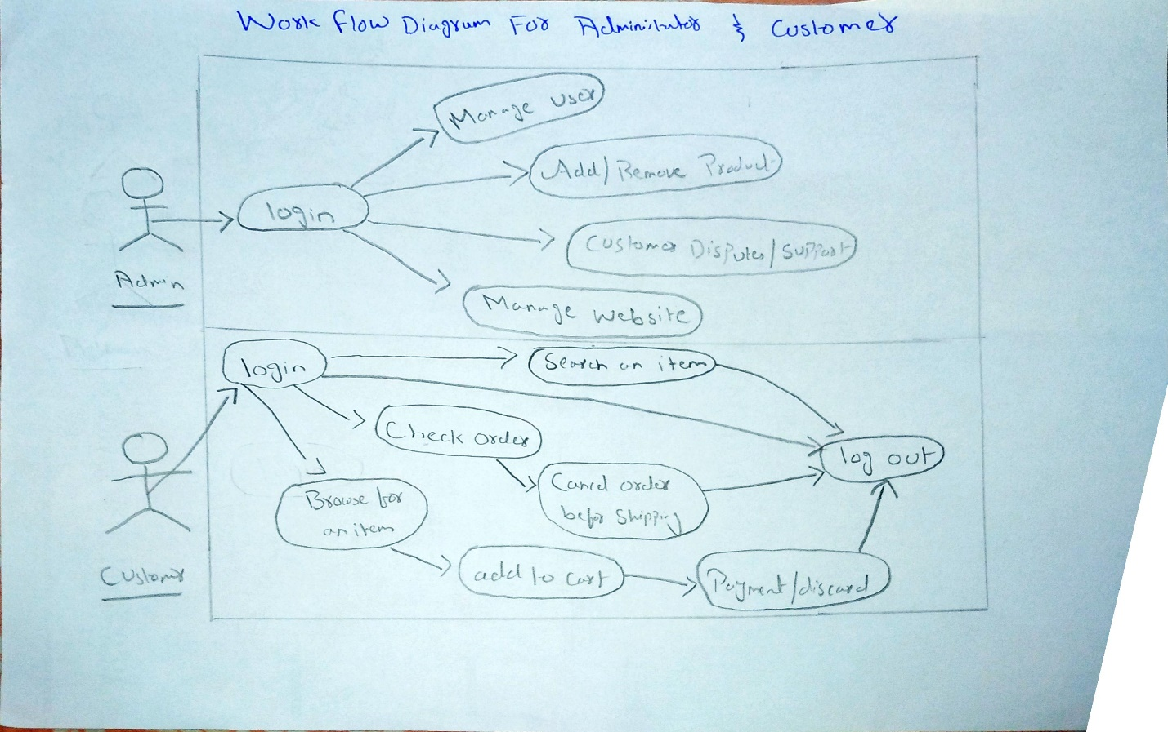

**3.2 Use Case**

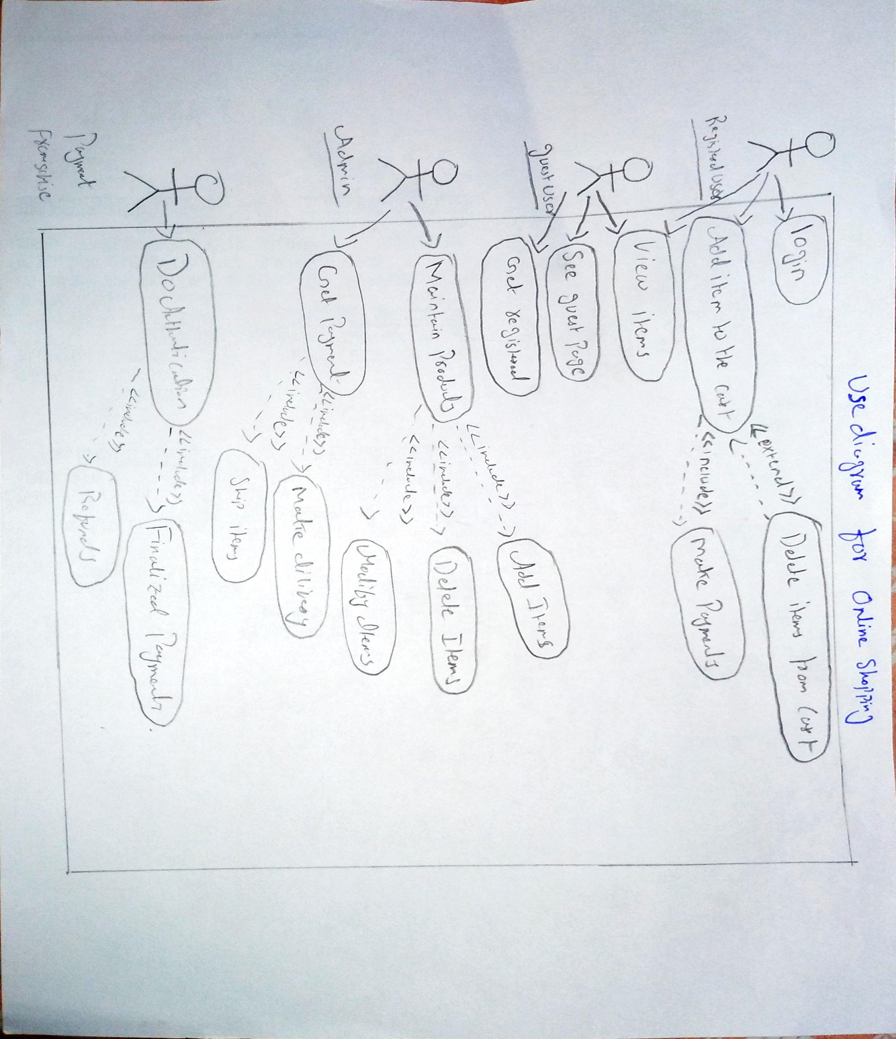

The first steps for the functional requirement collection are the use cases. Use cases are “a description of set of sequences of actions, including variants, that a system performs that yield an observable result of value to an actor”. They are used in order to: design system from user’s perspective, communicate system behavior in user’s term and enumerate all externally visible behavior.

**3.3 UML Class Diagram**

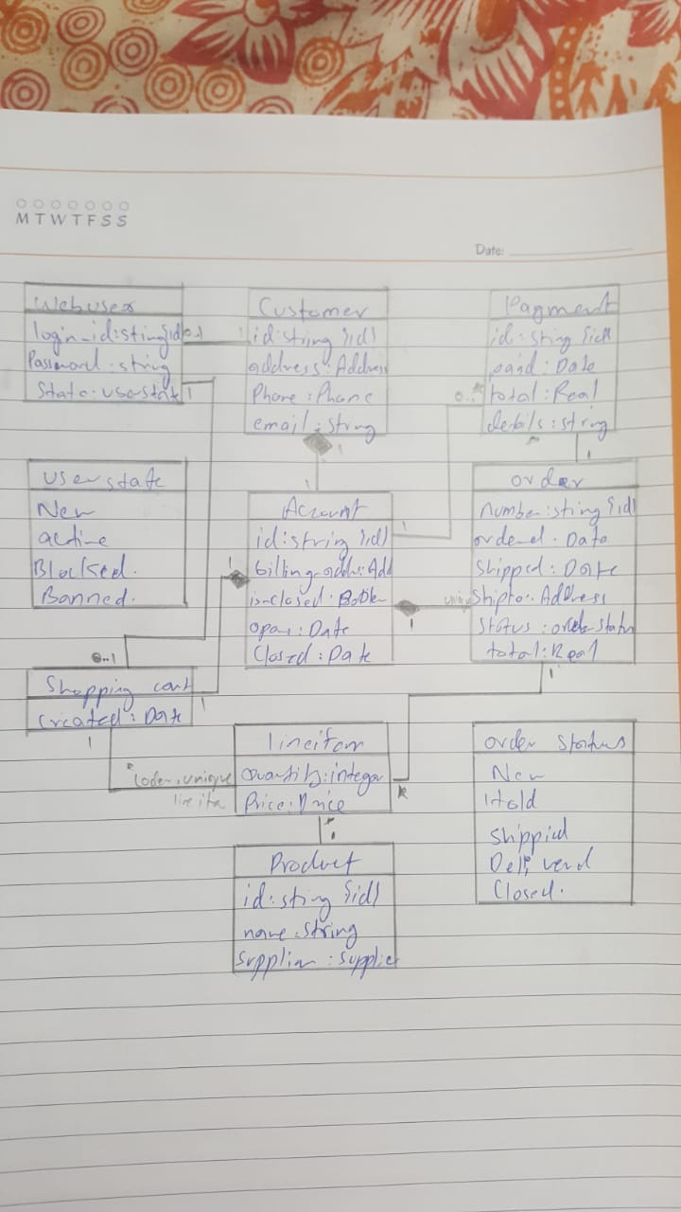

The next step of the design phase is to draw an UML Class Diagram of the system. Since the programming language of the system is an object oriented one, an UML Class Diagram is particularly adapted to show the classes of the system, their interrelationships, and the operations and attributes of the classes. Here is the class diagram of the project.

**3.4 STRUCTURE DIAGRAM**

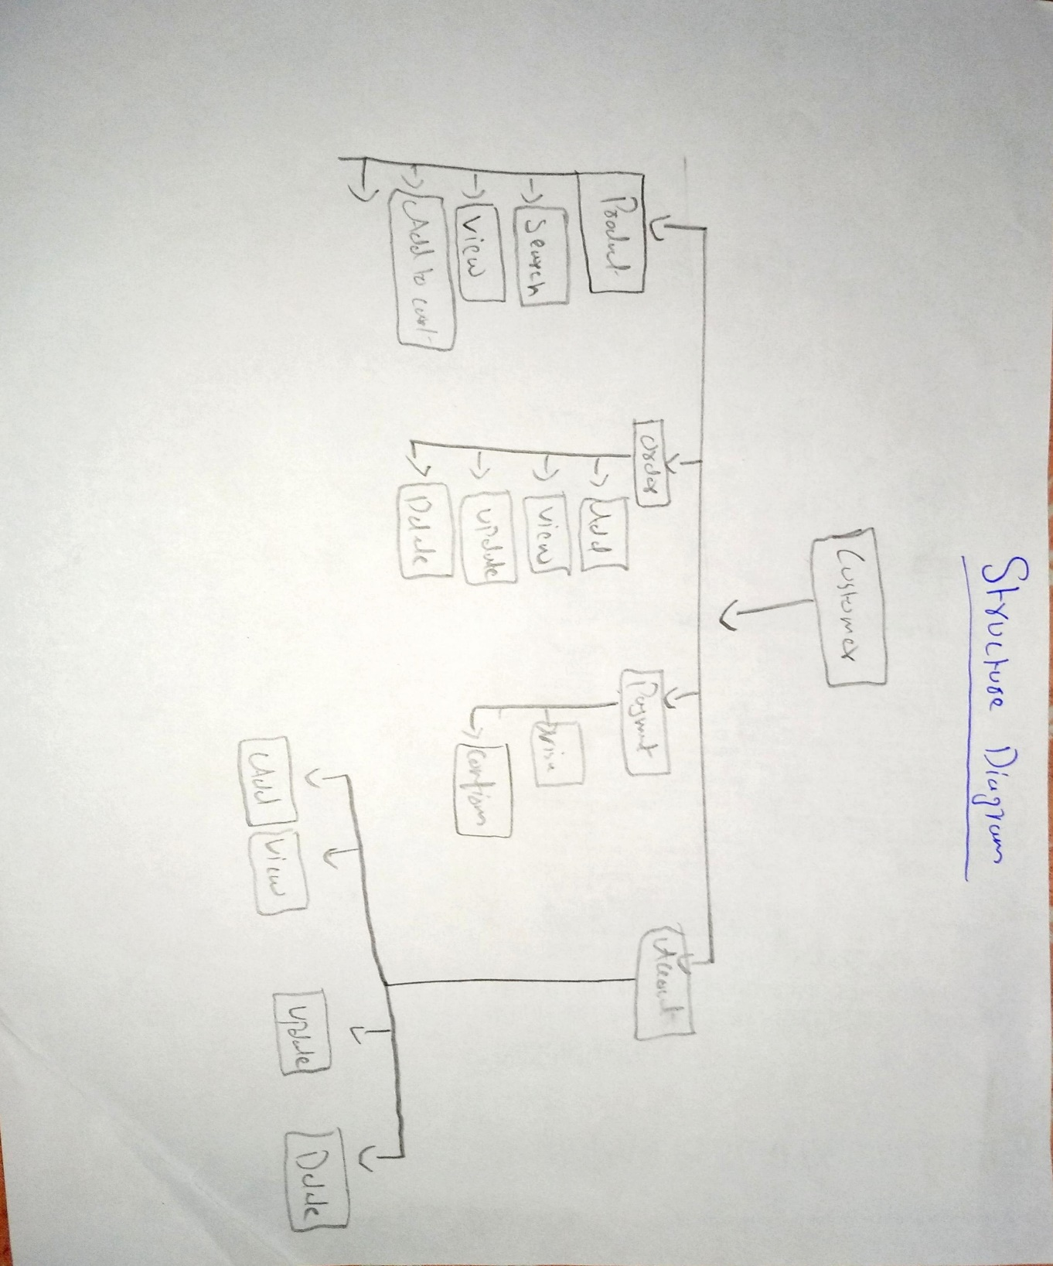

The next step of the design phase is to draw a Structure diagram of the system. This diagram shows the working scope of an administrator and normal users. Here is the structure diagram of the project.

**3.5 Collaboration diagram:**

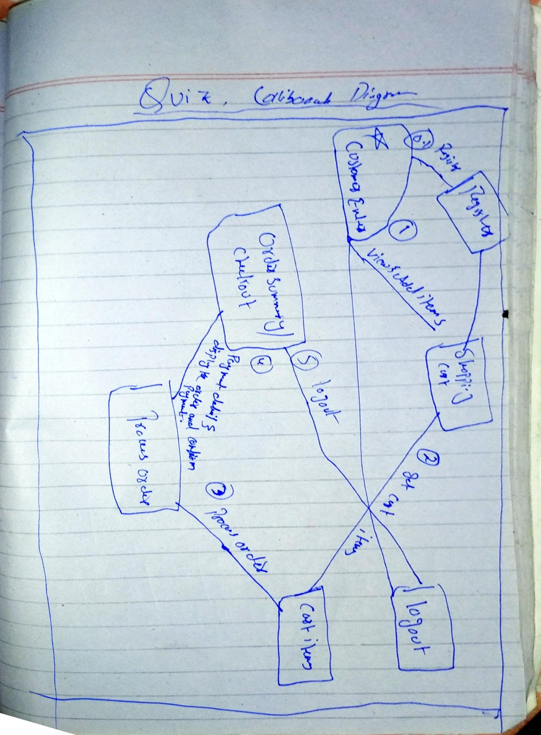

**3.6 State Chart Diagram**

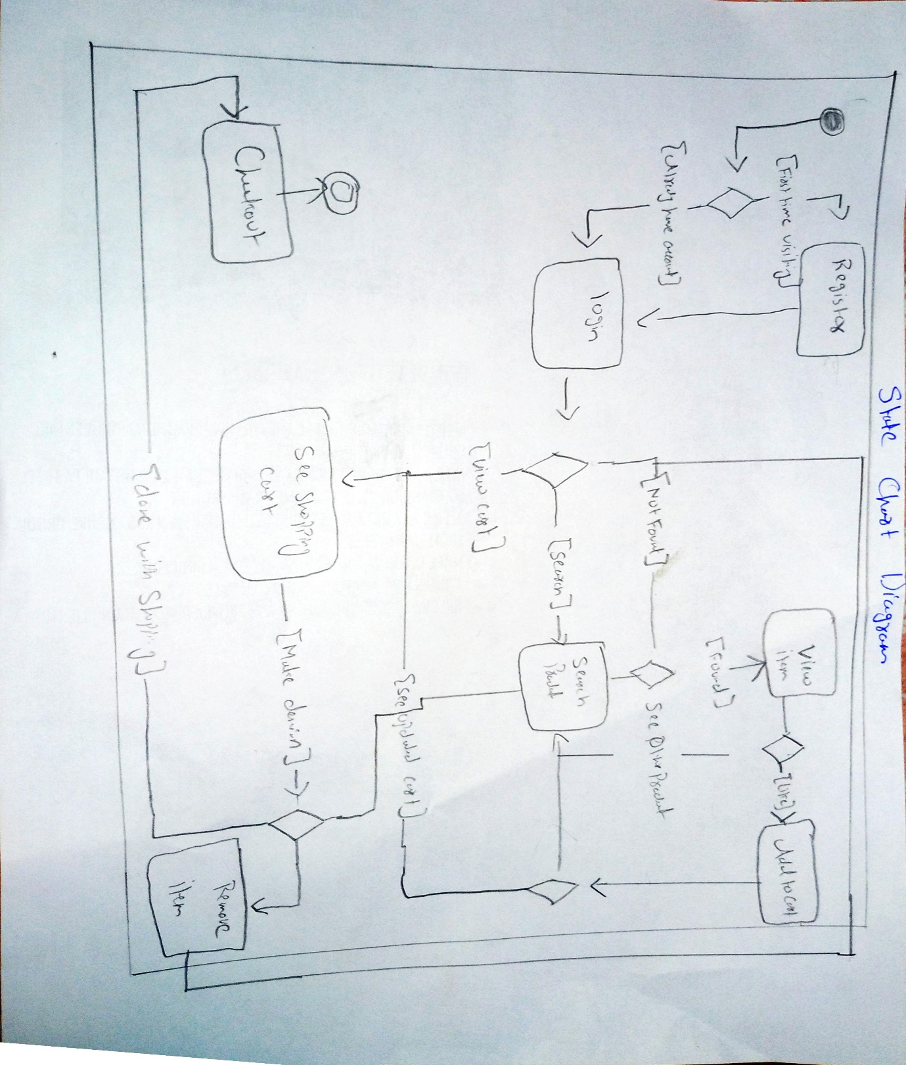

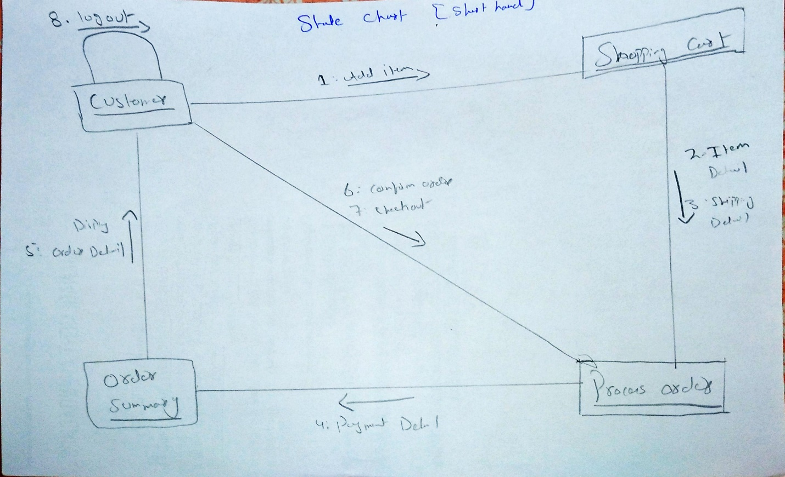

**3.7 Activity Diagram**

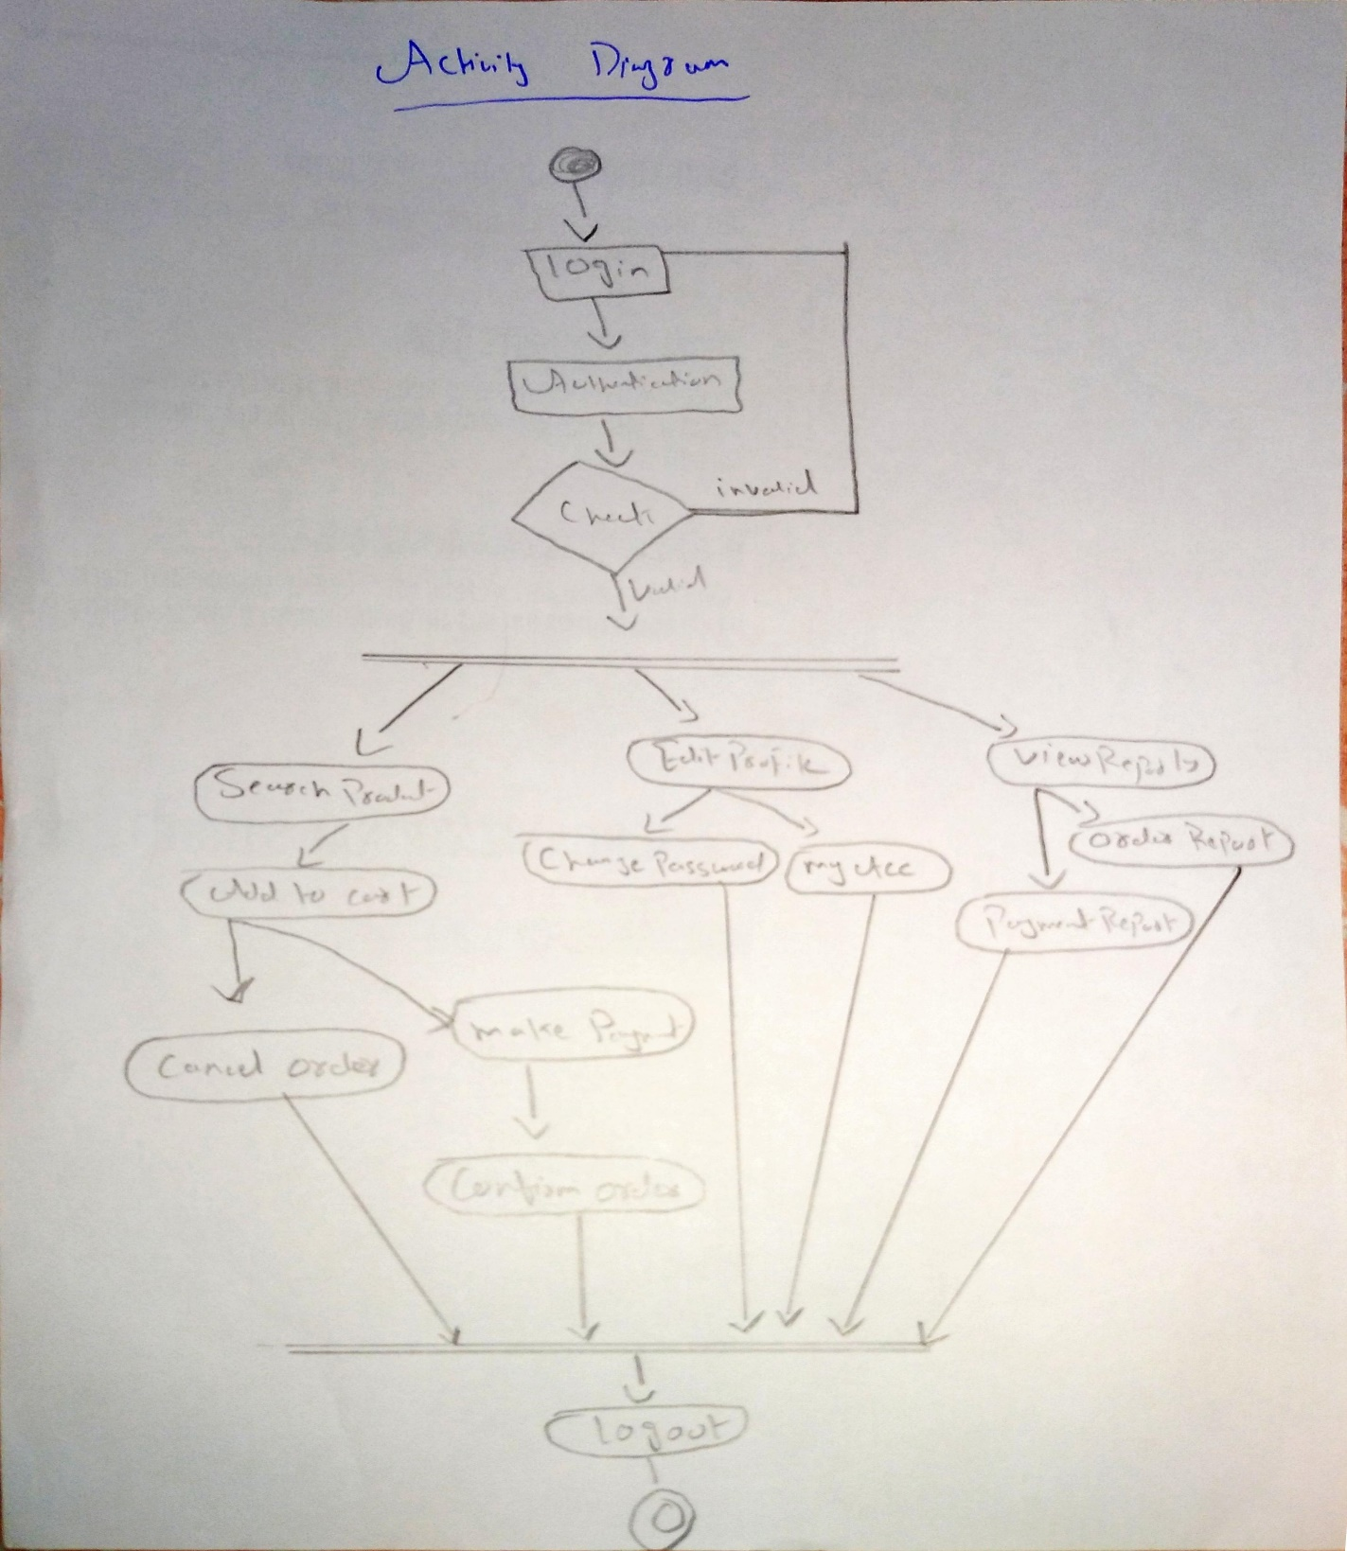

**3. REQUIREMENT ANALYSIS**

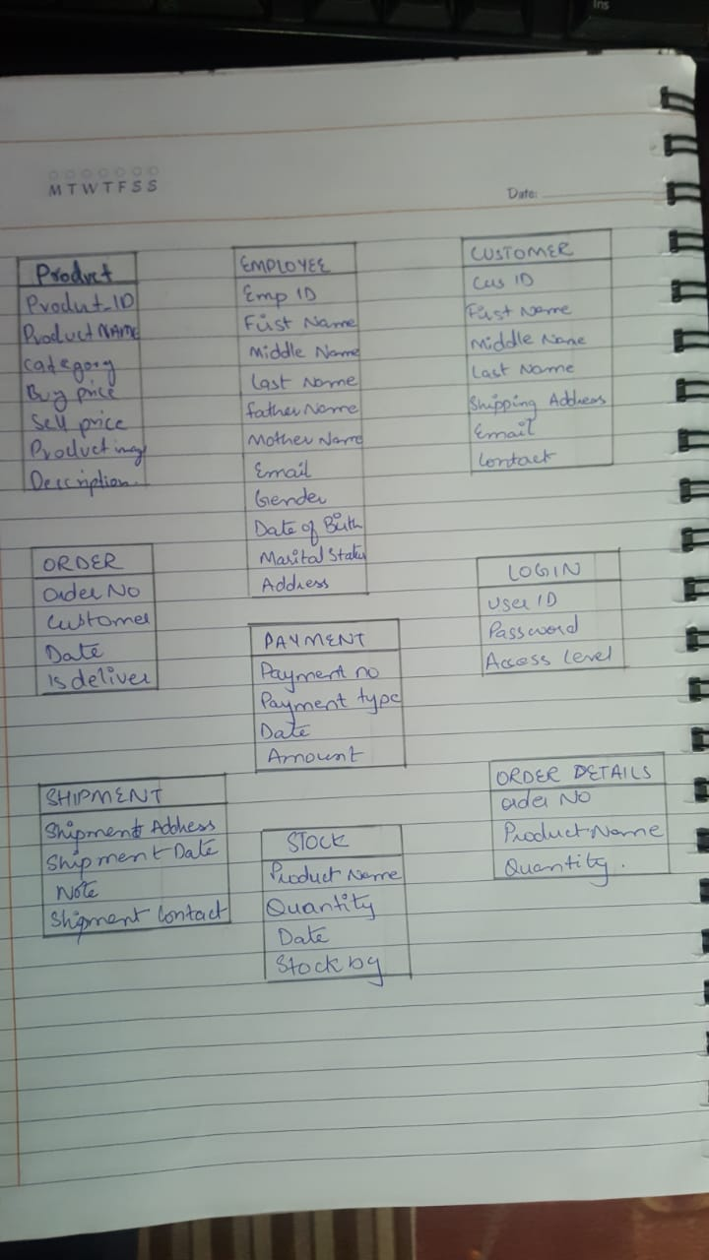

**4.1 Final Relationship Diagram**

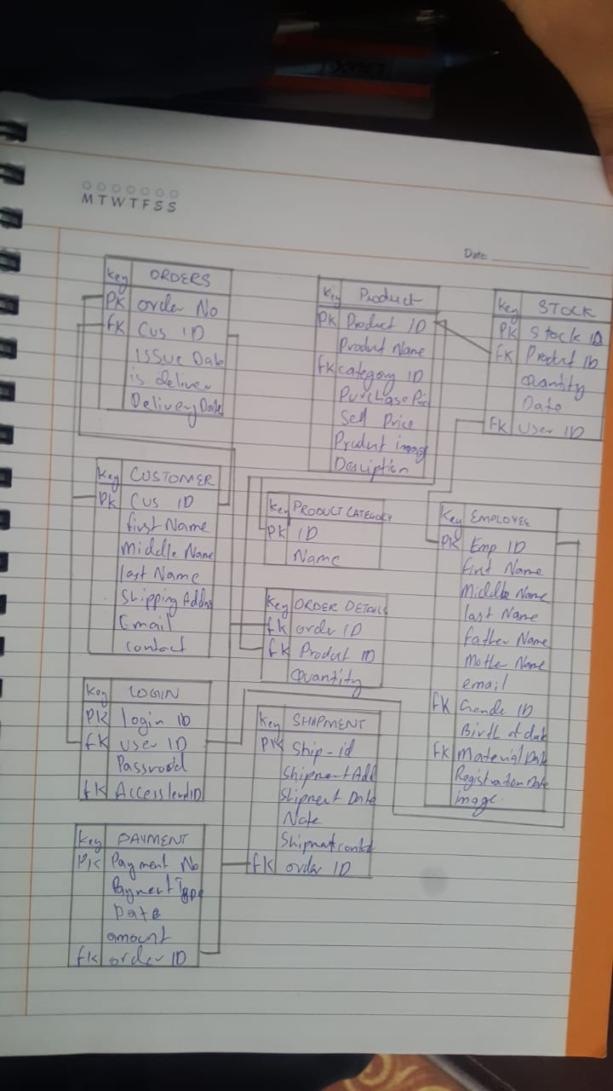

**4.1 Data Flow Diagram**

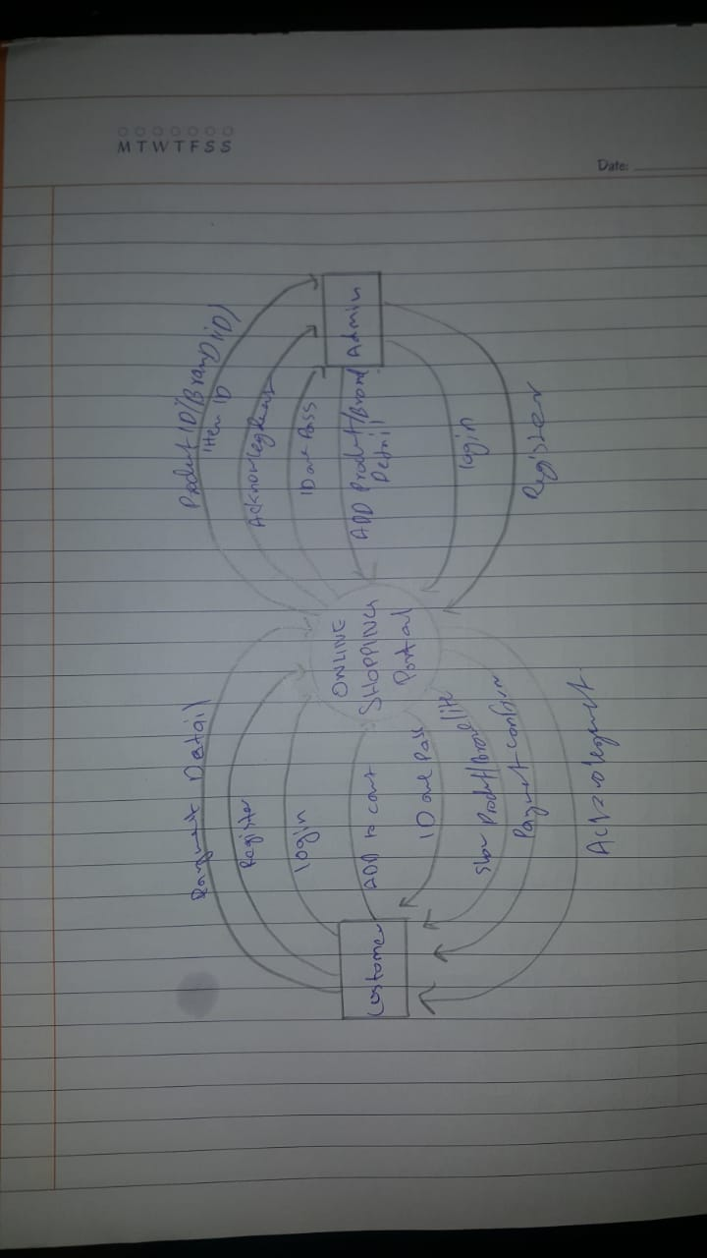

**Conclusion**

5.1 Conclusion

In this project we have represented an efficient way of developing dynamic website by using power of C# MVC and My SQL. Still little limitation exists in the software;, our aim is to develop this web site up to highly useful. The Internet has become a major resource in modern business, thus electronic shopping has gained significance not only from the entrepreneur’s but also from the customer’s point of view. For the entrepreneur, electronic shopping generates new business opportunities and for the customer, it makes comparative shopping possible. A good shopping cart design must be accompanied with user-friendly shopping cart application logic. It should be convenient for the customer to view the contents of their cart and to be able to remove or add items to their cart. The shopping cart application described in this project provides a number of features that are designed to make the customer more comfortable. This project helps in understanding the creation of an interactive web page and the technologies used to implement it. The design of the project which includes Data Model and Process Model illustrates how the database is built with different tables, how the data is accessed and processed from the tables. The building of the project has given me a precise knowledge about how MVC is used to develop a website, how it connects to the database to access the data and how the data and web pages are modified to provide the user with a shopping cart application. This project helps in understanding the creation of an interactive web page and the technologies used to implement it.

**REFERENCES**

[1] <https://en.wikipedia.org>

[2] https://www.scribd.com

[3 ]<https://www.academia.edu>

[4] https://www.tutorialspoint.com